**SQL Keyword Execution**

1. **FROM keyword:**

The FROM clause either names a single table or view or produces an intermediate result table that is the result of a subselect or an inner or outer join operation. The FROM command is used to specify which table to select or delete data from.

1. **WHERE keyword:**

The WHERE clause is used to filter records.

It is used to extract only those records that fulfill a specified condition.

WHERE Syntax

SELECT *column1*,*column2, ...*  
FROM *table_name*  
WHERE *condition*;

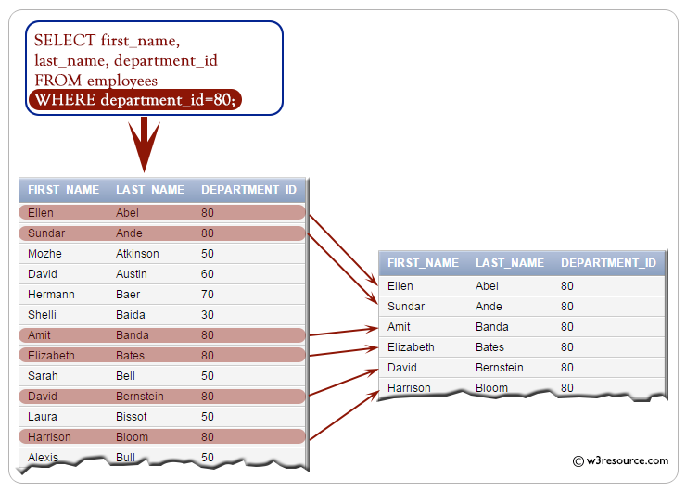

1. Pets who are dogs
2. Pets with age of greater than 5.
3. **GROUP BY keyword:**

The GROUP BY statement groups rows that have the same values into summary rows, like "find the number of customers in each country".

The GROUP BY statement is often used with aggregate functions (COUNT(), MAX(), MIN(), SUM(), AVG()) to group the result-set by one or more columns.

GROUP BY Syntax

SELECT *column_name(s)*  
FROM *table_name*  
WHERE *condition*  
GROUP BY *column_name(s);*

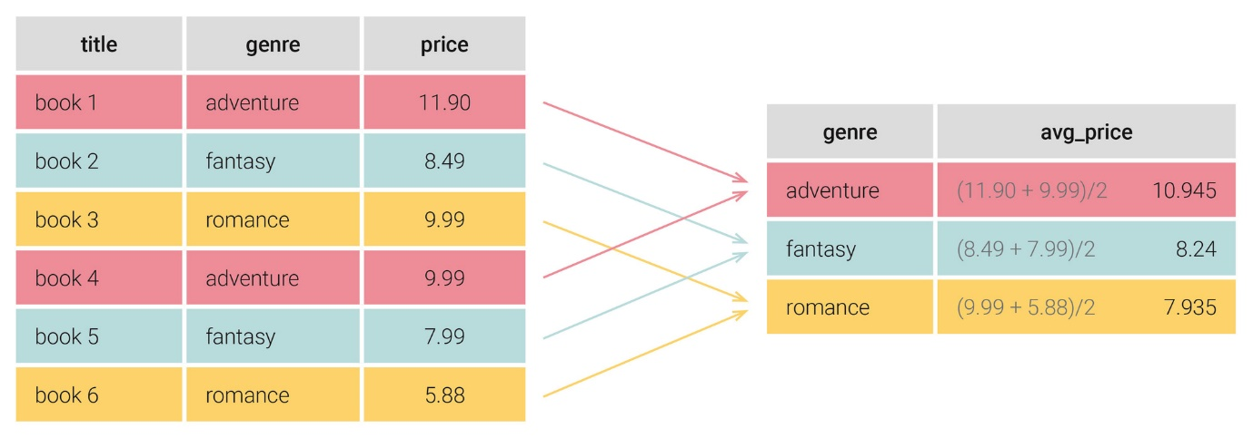

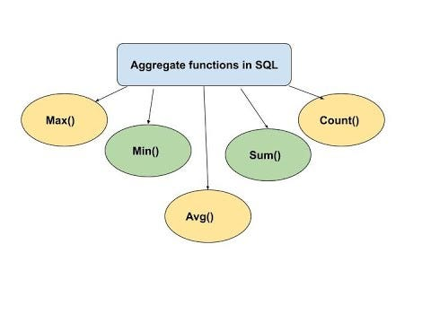

1. Count number of cats
2. Calculate average age of each kind
3. Minimum and maximum age of males and females.
4. **HAVING keyword:**

The HAVING clause was added to SQL because the WHERE keyword cannot be used with aggregate functions.

HAVING Syntax

SELECT *column_name(s)*  
FROM *table_name*  
WHERE *condition*  
GROUP BY *column_name(s)*HAVING *condition;*

1. Find the kind of pets that have a count of more than 3
2. Kind of pets whose average age is equal to 7
3. **SELECT keyword:**

The SELECT statement is used to select data from a database.

The data returned is stored in a result table, called the result-set.

SELECT Syntax

SELECT *column1*,*column2, ...*  
FROM *table_name*;

1. **ORDER BY keyword:**

The ORDER BY keyword is used to sort the result-set in ascending or descending order.

The ORDER BY keyword sorts the records in ascending order by default. To sort the records in descending order, use the DESC keyword.

ORDER BY Syntax

SELECT *column1*,*column2, ...*  
FROM *table_name*  
ORDER BY *column1, column2, ...*ASC|DESC;

1. Retrieve pet names in alphabetical order
2. Sum of age of each kind with highest sum on top
3. **TOP keyword:**

The TOP clause sets A LIMIT on the number of tuples returned by SQL

TOP Syntax

SELECT TOP number|*percent* column_name(s)  
FROM table_nameWHERE condition;

1. Retrieve top 10 records in table
2. Fetch most oldest 5 pets.